**Requirements Document**

**Project:** ECSE211 Design Project – Capture the Flag

**Task:** Construct an autonomous robot that can play one-on-one version of the game Capture the Flag

**Document Version Number:** Version 1.7

**Date:** November 28, 2017

**Author:** Priscilla Ip

**Edit History:**

- Created: 15/10/2017

|  |  |  |  |
| --- | --- | --- | --- |
| **Date** | **Edited By:** | **Section** | **Reason** |
| Oct. 15, 2017 | Priscilla | Operating Environment, Constraints, Performance | Added these sections |
| Oct. 15, 2017 | Paarth | Purpose, Scope | Added these sections |
| Oct. 15, 2017 | Younes | Compatibility, User Functions | Added these sections |
| Oct. 19, 2017 | Priscilla | Scope | Answered Questions |
| Oct. 20, 2017 | Priscilla | Author | Changed to single author |
| Oct. 26, 2017 | Priscilla | Purpose | Updated Diagram |
| Nov. 7, 2017 | Priscilla | Performance | Added Beta Demo Requirements |
| Nov. 14, 2017 | Priscilla | Performance | Removed Beta Demo Requirements; Added pointer to Beta Demo Review Document |
| Nov. 24, 2017 | Priscilla | Format, Purpose, Scope | Updated to current format, updated purpose and scope |
| Nov. 28, 2017 | Priscilla | Table of Contents | Added links |

1. **Table Of Contents**

2.0 Capabilities…..………………………………………………………………………………... 3

2.1 Purpose……………………………………………………………………………….. 3

2.2 Scope…………………………………………………………………………………. 4

2.3 Constraints…………………………………………………………………………… 4

2.4 User Functions……………………………………………………………………….. 5

2.5 Operating Environment……………………………………………………………… 5

2.6 Performance………………………………………………………………………….. 5

3.0 Compatibility…………………………………………………………………………………... 5

3.1 Component Re-use………………………………………………………………….. 5

3.2 Compatibility with Third Party Products…………………………………………… 5

4.0 Glossary of Terms……………………………………………………………………………. 6

5.0 References……………………………………………………………………………………. 6

1. **Capabilities**

**2.1** **Purpose**

The purpose of this lab is to traverse predetermined sections of the floor to effectively detect and capture the opponent’s flag and return to home base. The flag is a coloured foam block and a capture is denoted by three beeps. This is best described as playing a one-on-one game of Capture the Flag.  The predetermined sections are illustrated in *Figure 2.1.1*below. As there are two different methods to navigate to the enemy zone, the product is intended to complete the following tasks:

1. Receive the set of game parameters which describe the layout of the playing field
   1. Coordinates of Players’ Zones (Red, Green)
   2. Coordinates of Virtual River (Blue)
   3. Coordinates of Shallow Water (Grey)
   4. Coordinates of the Zip Line
   5. Coordinates of the Search Zone
   6. Colour of the Flag
2. Localize to the closest intersection when started
3. Receive method to traverse the river
   1. Using the Overhead Zip Line
   2. Rolling through Shallow Water
4. Be proficient in crossing using either method
5. Navigate using appropriate traversing method from starting location to the opponent’s zone
6. Avoid obstacles that may be on the navigating route
7. Recognize the opponent’s zone has been entered
8. Search for the opponent’s flag without pushing any flags beyond the search zone
9. Successfully capture flag and return to starting corner

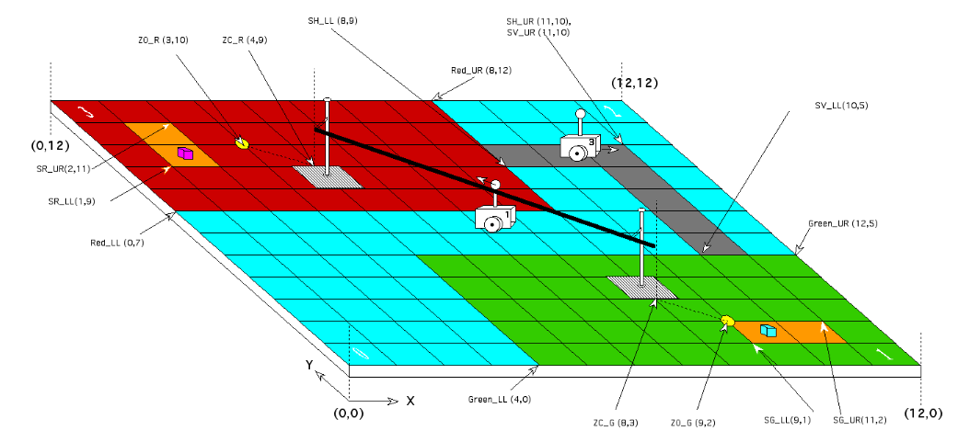

*Figure 2.1.1: Visual of the Playing Field*

**2.2** **Scope**

Refer to [*Constraints Document*](Constraints%20Document.docx)for a complete overview of the constraints imposed on the task.

As the product is limited to a 6.5-week timeline, a functioning product is preferred over the *best* product. This means the product has limitations pertaining to the resources available, budget available, hardware constraints and software constraints. The following is known for the project:

* Size of area in which product will function – 12’ x 12’ grid where the block size is 30.48cm and the origin is located at the lower left hand corner of *Figure 2.1.1*
* Material of area – smooth wooden surface, metal bar
* Material of flag – foam blocks
* Time-limit in which to complete flag capture task
  + 5 minutes to complete the entire task
  + 30 seconds to localize to nearest intersection after starting
* If the goal of shareholders has been met there is no need for improvement before presentation of product
* There may be more than one coloured block in the search zone
* The shallow water crossing can only consist of full tiles
* The flags are placed once the robots have passed their own search zone as to avoid collisions
* Size of the search zone can vary

In essence, the limitations within which the product is to be manufactured and the performance criteria of the product have to be explicitly well-known.

**2.3** **Constraints**

Refer to [*Constraints Document*](Constraints%20Document.docx)for a complete overview of the constraints imposed on the task

**2.4** **User Functions**

According to the supplied project description, the robot must be supplied with coordinate information over Wi-Fi prior to starting the task, using a Java class provided by the client. After that, no further user interaction is permitted, since the robot will complete its task autonomously. Therefore, the robot will be set up in batch mode. To indicate to users that a flag has been captured, the robot beeps three times.

**2.5** **Operating Environment**

Refer to Section “[2.0 Environmental Issues](Constraints%20Document.docx#Environmental_Issues)” in the [*Constraints Document*](Constraints%20Document.docx)for a description of how the operating environment affects the performance of the system.

The robot will operate on the provided 12’ x 12’ smooth wooden playing floor with grid lines, which is composed of nine testing floors used in the R&D labs. The competition location is the Lorne Trottier building on the second floor. This operating environment comes with a unique set of challenges when it comes to ambient lighting and natural lighting from the large windows, which are very different from the conditions found in the main testing location (DPM Lab in the basement). These differences in lighting influence how we develop the light localization to take light changes in effect. The ultrasonic sensors should not be affected by external sounds but testing will be done to ensure this fact. However, ultrasonic sensors could be affected by temperature fluctuations [1].

**2.6** **Performance**

The qualitative performance requirements are mentioned in this document in Section “2.1 Purpose” and the time requirements are mentioned in Section “2.2 Scope”. In the worst case scenario where the robot and the flag are placed in opposite corners, the distance travelled will be approximately 4 lengths of the playing field, namely 14.6m.

In addition to the performance requirements of the final competition, there was a beta demo with specific tasks that the robot should be able to complete. These requirements along with the performance outcomes are described in the [*Beta Demo Review Document*](Beta%20Demo%20Review%20Document.docx)*.*

1. **Compatibility**

**3.1** **Component Re-use**

As mentioned in Sections “[4.0 Software Available and Capabilities](System%20Document.docx#Software)” and “[5.0 Hardware Available and Capabilities](System%20Document.docx#Hardware)” in the [*System Document*](System%20Document.docx), we will reuse many concepts from the R&D labs, including hardware designs and software classes. In addition, we could make use of any relevant third party open source LeJOS software. This component reuse will allow us to save time and to allocate more resources to testing and refining our product.

**3.2** **Compatibility with Third Party Products**

Although it is not mentioned in the client specification, Lego Mindstorms is compatible with other hardware systems, such as conventional Lego and K’nex (a competing building system) via inexpensive adapters. Therefore, our final design could include some additional hardware components. The system we are building is required to connect to Wi-Fi, and indeed it has that capability, which we already tested during the labs.

The EV3 runs an embedded Linux system that is compatible with many technologies, including Java, SSH, C, and even assembly. However, the client requires that a certain Java class must be used to upload information to the robot. It is very difficult and cost-prohibitive to mix languages (e.g. C and Java) at this scale, so all the code that executes on the EV3 will be written in Java.

1. **Glossary of Terms**

* Ambient Light Level: the amount of light in the environment when there is no light provided by the system
* Batch Mode:automated processing without human intervention
* R&D Lab: the research and development labs that were conducted prior to starting the project

1. **References**

|  |  |
| --- | --- |
| [1] | Banner Engineering, "Ultrasonic Sensors 101: Answers to Frequently Asked Questions". Available: bannerengineering.com/us/en/company/expert-insights/ultrasonic-sensors-101.html. [Accessed: 17-Oct-2017]. |